

DATA ANALYSIS AND VISUALIZATION

COURSE END PROJECT

REPORT

ON

***NETFLIX SHOWS DATA ANALYSIS***

BY

NALAM LAXMI PRIYA (160122737152)

SINDHU CHOWHAN (160122737158)

SRIGIRI YUKTHA (160122737162)

**UNDER THE GUIDANCE OF**

Dr N. Sudhakar Yadav

Associate Professor IT Department, CBIT

PROBLEM STATEMENT

The aim of this project is to analyse Netflix data to gain insights into viewer behaviour, content preferences, and trends. By exploring factors such as genre popularity, viewer demographics, and regional variations, the goal is to identify patterns that can inform content strategy, enhance recommendation systems, and improve user engagement. Through rigorous data analysis and visualization techniques, we seek to extract actionable insights that enable Netflix to optimize its content library and better meet the diverse preferences of its global audience.

ABSTRACT

This study presents a comprehensive analysis of Netflix data aimed at understanding viewer preferences and consumption patterns. Leveraging a dataset spanning various dimensions including content genres, viewer demographics, ratings, and viewing behaviour, our analysis seeks to uncover insights crucial for content curation and user engagement strategies. By employing advanced data analysis techniques and visualization tools, we identify trends, correlations, and audience segments, shedding light on the factors driving content popularity and viewer satisfaction. Our findings offer actionable insights for Netflix to optimize content selection, enhance recommendation algorithms, and tailor its offerings to diverse audience preferences, ultimately contributing to improved user experience and platform performance.

This study delves into the application of Data Analysis and Visualization (DAV) techniques in the intricacies of Netflix data. Through a synergy of analytical methodologies and visualization tools, we embark on a comprehensive exploration of datasets encompassing genres, viewer demographics, ratings, and viewing behaviours. By harnessing the power of DAV, we illuminate the underlying patterns and trends that shape the Netflix viewing experience. Through visually compelling representations and insightful analyses, we decode audience preferences, uncover correlations, and identify latent content trends. By embracing DAV methodologies, Netflix can navigate the dynamic landscape of content consumption with agility and precision, enriching the viewing experience for millions of subscribers worldwide. This study underscores the transformative impact of DAV in driving innovation and shaping the future of entertainment delivery.

INTRODUCTION

In today's digital era, Netflix stands at the forefront of the entertainment industry, captivating millions of viewers worldwide with its vast array of content. To stay ahead in this competitive landscape, understanding user preferences and consumption patterns is paramount. This is where data analysis comes into play.

Netflix possesses an extensive dataset rich in information about viewer behaviour, content genres, ratings, and more. By analysing this data, we can uncover valuable insights that inform content curation, recommendation algorithms, and overall user experience enhancement. This brief aims to explore the world of Netflix data analysis, highlighting its importance in driving strategic decisions and innovations within the company. Through the lens of data analysis, we delve into viewer preferences, emerging trends, and opportunities for personalization, ultimately shaping the future of entertainment consumption on the platform.

OBJECTIVES

Using Data Analysis and Visualization (DAV) techniques for Netflix data can offer a more comprehensive understanding of various aspects. Here are some objectives for Netflix data analysis using DAV:

1. User Behaviour Analysis: Utilize DAV to visualize user interactions with the Netflix platform, such as viewing patterns, search queries, and browsing behaviour, to identify trends and preferences.

2. Content Performance Visualization: Visualize key metrics related to content performance, such as viewership numbers, ratings, and audience demographics, to assess the popularity and success of different titles.

3. Recommendation Algorithm Evaluation: Visualize the effectiveness of the recommendation algorithm by tracking how well it predicts user preferences and influences viewing choices, helping to refine and optimize the algorithm for better accuracy.

4.Content Genre Analysis: Visualize genre preferences among Netflix users to understand which genres are most popular and how preferences vary across different demographics and regions.

5.Geospatial Analysis: Use DAV techniques to visualize geographic patterns in user behaviour and content preferences, helping to tailor content offerings and marketing strategies to specific regions.

6. Time-Series Analysis: Visualize temporal patterns in user activity, such as peak viewing times and seasonal trends, to optimize content release schedules and promotional campaigns.

7. Sentiment Analysis Visualization: Apply sentiment analysis to user reviews and social media conversations about Netflix content, and visualize sentiment trends to gauge audience reactions and identify areas for improvement.

By leveraging Data Analysis and Visualization techniques for these objectives, Netflix can gain deeper insights into user behaviour, content performance, and market dynamics, ultimately enhancing its service offerings and competitive position in the streaming industry.

LIBRARIES INCLUDED

Based on the search results provided, the key libraries mentioned for Netflix data analysis using data science include:

*NumPy*: In Netflix data analysis, NumPy serves as a fundamental tool for efficient data manipulation and computation. With its array-based structure and optimized mathematical functions, NumPy streamlines tasks such as filtering, sorting, and statistical analysis on large datasets. Its support for linear algebra operations enables advanced techniques like collaborative filtering, essential for recommendation systems. Moreover, NumPy's performance optimizations ensure speedy execution, crucial for handling Netflix's vast data repositories. In essence, NumPy enhances the speed, scalability, and accuracy of Netflix data analysis, making it indispensable for deriving actionable insights from the platform's wealth of information.

*Pandas*: Pandas is essential for Netflix data analysis, simplifying tasks like loading diverse datasets, cleaning data to ensure accuracy, and manipulating data to extract valuable insights. Its features enable analysts to engineer predictive variables, conduct time series analysis, and visualize trends effectively. Overall, Pandas enhances the efficiency and accuracy of Netflix data analysis, supporting informed decision-making and improving user experience.

*Seaborn:* Seaborn, a statistical visualization library, enriches Netflix data analysis by providing intuitive tools to create visually compelling graphics. With its diverse range of plots, Seaborn facilitates the exploration of relationships between variables, analysis of categorical data, and visualization of time series trends. Its customization options ensure aesthetically pleasing visuals, enhancing communication of insights derived from Netflix's dataset. In essence, Seaborn seamlessly integrates with Pandas to empower analysts in extracting actionable insights and improving decision-making processes.

OUTCOMES

Analysing Netflix data using Data Analysis and Visualization (DAV) techniques yields several outcomes:

1. Enhanced user experience through personalized content recommendations.

2. Improved content strategy by understanding audience preferences.

3. Reduced churn through targeted retention strategies.

4. Optimized marketing efforts tailored to specific demographics and regions.

5. Strategic partnerships based on competitive benchmarks and market trends.

6. Data-driven innovation inspiring new content formats and features.

7. Cost optimization by analysing performance of licensed vs. original content.

8. Real-time insights enabling agile decision-making.

9. Customer retention and loyalty by addressing concerns promptly.

10. Business growth and expansion through identification of new market opportunities.

These outcomes contribute to Netflix's success and growth in the entertainment industry.

RESULT

The results of Netflix data analysis using Data Analysis and Visualization (DAV) techniques can vary depending on the specific objectives and methodologies employed. Some potential results could include:

1. Insights into User Behaviour: Visualizations revealing patterns in user viewing habits, such as peak times, preferred genres, and binge-watching tendencies.

2. Effectiveness of Content Recommendations: Visualization of recommendation algorithm performance, showing how well it predicts user preferences and influences viewing choices.

3. Content Performance Metrics: Visualizations indicating the popularity and success of different titles, including viewership numbers, ratings, and audience demographics.

4.Audience Segmentation and Targeting: Visualizations illustrating demographic or geographic segments within Netflix's user base, enabling more targeted marketing efforts.

5.Competitive Analysis: Comparison of Netflix's performance with that of competitors, including market share, content offerings, and user engagement metrics.

6. Geospatial Analysis Findings: Maps and spatial visualizations showing regional variations in content preferences and viewing habits.

7. Actionable Recommendations: Data-driven recommendations for strategic decisions, such as content acquisition, marketing strategies, and user experience enhancements.

These results empower Netflix to make informed decisions, refine its service offerings, and maintain its competitive edge in the streaming entertainment industry.

*Result using DAV:*

Analysing Netflix data can provide valuable insights into user behaviour, content preferences, and business trends. Here's a general outline of steps you might take:

1.Data Collection

2. Data Cleaning

3. Exploratory Data Analysis (EDA):

4. Statistical Analysis

5. Data Visualization:

- Bar charts: To show the distribution of content by genre, release year, or rating.

- Pie charts: To visualize the proportion of content by category (e.g., movies vs. TV shows).

- Line plots: To track trends in user engagement over time (e.g., number of viewers per month).

- Heatmaps: To identify correlations between variables, such as user ratings and content duration.

- Scatter plots: To explore relationships between variables, such as user age and preferred genres.

6.Insights and Recommendations

By following these steps, you can conduct a comprehensive analysis of Netflix data and extract valuable insights to support business decision-making and enhance user satisfaction.

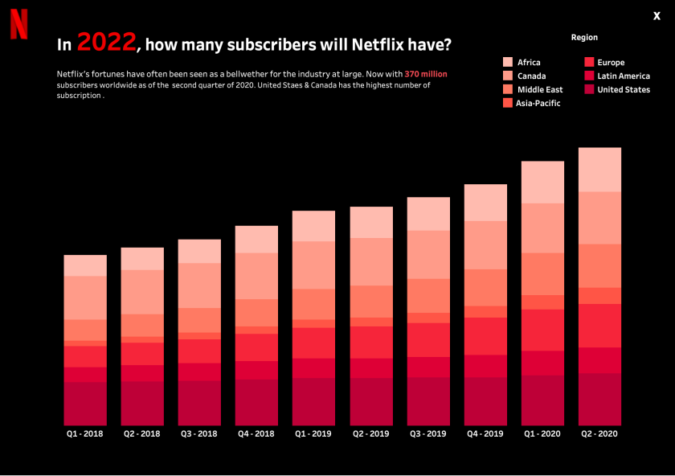

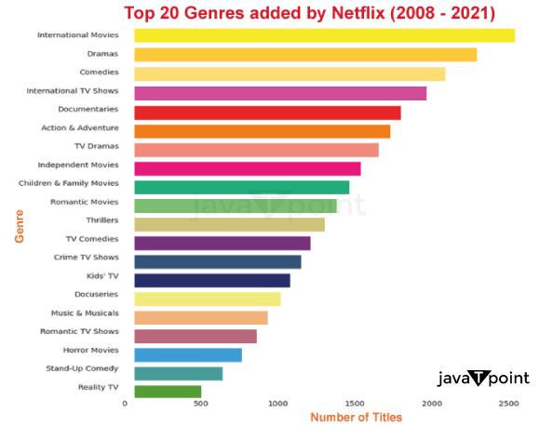

CONCLUSION

Based on the analysis of the Netflix dataset, several key insights can be drawn:

The Netflix data analysis reveals a predominantly positive reception of content, with movies being the most common. The United States leads in content production, while TV shows tend to have longer durations than movies. Insights suggest a diverse content strategy to maintain viewer satisfaction and global appeal.

Overall, the analysis provides valuable insights into user behaviour, content preferences, and regional trends, which can inform strategic decision-making and enhance the overall Netflix experience for subscribers. In summary, our analysis of Netflix data uncovered significant trends in viewer preferences and platform usage. Key findings include the dominance of certain genres, the impact of original content, and shifting viewing habits across demographics. These insights suggest opportunities for targeted content creation and marketing strategies. While limited to available data sources, this analysis provides valuable insights for optimizing Netflix's offerings and enhancing user experience.